

**Black Box Agility  
iPath Backups / Satellites & Multi-Subnet***updated by Garrett Swindell 2/9/2017*

This document will cover several items related to the iPath manager including:

* Overview
* iPath Terminology
* Pre-Requisites
* Adding a Backup iPath
* Setting up a Backup iPath
* Adding a Satellite iPath
* Setting up a Satellite iPath
* Factory Resetting iPath managers
* Multi-Subnet DHCP Option 125
* Multi-Subnet examples and configuration

**Overview:**This document describes how to add a backup iPath to a primary iPath server, along with additional details on how to prepare for maintenance. Adding a backup controller provides redundancy and allows the Agility endpoints (*transmitters and receivers*) to continue to operate and channel change in the event of an iPath failure.

From iPath firmware 4.1 and above, the ability to support endpoints on different subnets was added. This allows Agility endpoints to be scaled up to thousands of endpoints. In order to implement the multi-subnet feature, a DHCP Server is required to issue IP addresses to the endpoints and let them know where to find the iPath servers.

The DHCP Server can either be provided by iPath itself when set in a non-subnet mode or via an external DHCP Server when iPath is set to subnet mode. Multi-Subnet mode is a decision that is made when initially configuring the Primary iPath from a factory default state.

This document does not cover how to configure an external DHCP server as there are many servers and configuration methods; however there are examples at the end. It also assumes that you have some DHCP configuration knowledge and that the chosen server can support option 125.

**iPath Terminology:   
Primary:** This is the master server in charge of the system  
**Backup:** A server on the same subnet as the primary for redundancy  
**Satellite:** A backup server, but on a different subnet to the Primary

The backup and satellite iPath controllers hold a synchronized copy of the primary iPath database/configuration; however neither can change the configuration of the endpoints. Only the Primary can change the configuration including adding/removing endpoints, channels and presets.

In order to have satellite iPath controllers on different subnets, the primary iPath must be configured in Multi-Subnet mode.

**Pre-requisites:**To add a backup or satellite iPath it is important that the following pre-requisites are reviewed.

* All iPath controllers must be running the same firmware version
* The end point license must be the same on all iPath controllers
* The cluster authentication on the primary iPath must be disabled
* The backup/satellite iPath must be in a fully reset factory state before connecting it to the network.
* Satellite iPath controllers are only supported form firmware version 4.2.37829 and above. The primary must be configured in multi-subnet mode.

When adding a backup it is important that:

* The primary iPath IP address is not set to the last IP address in a range (i.e. x.x.x.254). The backup iPath will be given the next available IP address after the primary, if the primary is at the end of the range, the backup cannot be created.

When adding a satellite iPath controller, it is important that:

* The IP address(s) that will be assigned to the satellite iPath(s) are included in the DHCP Option 125.

**Adding a Backup iPath:**When a backup iPath boots for the first time, it carries out a number of steps to check for the presence of other iPaths on the network.

The first check is to find a Primary iPath on the same subnet whose fixed link-local network address is 169.254.1.2. If discovered, it will request an IP address from the Primary iPath. This is typically the next available IP address, for example if the Primary is set to 192.168.1.1, the backup will be assigned 192.168.1.2.

*Note: It is not recommended that you assign a Primary iPath at the top end of the IP address range, for example 192.168.1.254. The primary iPath will not be able to assign a valid IP address to the backup.*

Once the backup has been given its network settings from the Primary iPath, a TLS trust is established between the two using private and public keys. This is used to encrypt the communications between the iPaths and endpoints.

The database will be synchronized between the Primary and Backup iPath controllers. Depending on the size of the database, this can take up to 30 minutes to complete, although most will see this occur within 10 minutes. During this period, you can access the primary iPath controller web interface and see the status under the “Servers” tab. Whilst synchronizing the status will be shown as “Initializing”, however once completed this will change to “Standby”.

**How to setup a Backup iPath:**The default IP address for the iPath is 169.254.1.3. It is highly recommended that you directly connect to the Backup iPath while initially setting it up. This will prevent the Primary iPath from taking control prematurely.

Note: if the IP has been changed from the 169.254.1.3 address to a user defined address, you can still access the iPath controller using 169.254.1.2, even if you set the NIC up for 192.168.x.x

1. Make sure the Backup iPath is NOT on the same physical network as the Primary during initial setup.
2. Upgrade/Downgrade the firmware if necessary on the backup controller to match the Primary iPath firmware. You can find the firmware version on the webpage of the Primary controller. To upgrade, navigate to **Dashboard>>Updates**. Upload the appropriate iPath firmware and reboot when requested.
3. Check that the endpoint license is the same on the Primary as on the Backup. Navigate to **Dashboard>>Settings>>General**. At the bottom of the page is a license section that will inform you of the active license type. It is very important that they are the same. You can purchase additional endpoint licenses if required, please speak with Black Box about getting an updated endpoint license if you need one.
4. The cluster authentication must be disabled on the Primary iPath. Navigate to **Dashboard>>Settings>>Servers** on the Primary iPath. Click on “No” for “Require Authentication” and press the SAVE button.
5. Perform a full factory reset on the BACKUP iPath. (see section on Factory Resetting an iPath). **DO NOT FACTORY RESET THE PRIMARY!**
6. Connect the backup iPath to the Primary iPath network after it has been reset. Upon boot, the Primary iPath will automatically take control of the Backup iPath. It will assign it the next available IP address above its own (Primary: 192.168.1.5, Backup will be assigned 192.168.1.6).

If the backup iPath does not link with the Primary (you can check via using the new consequetive IP address), reboot the Backup controller again and see if it syncs. If it still does not sync, perform a factory reset on the BACKUP iPath again while on the same physical network as the Primary and it will link them.

1. You can check the progress by viewing the “Servers” page on the Primary iPath. During the database synchronization, the status for the backup iPath will be “Initializing”. Once complete, it will say “Standby”. It can take up to 30 minutes (normally 10 minutes) to synchronize the controllers. In this time, it is not recommended that you reboot either the Primary / Backup iPath controllers.

**Understanding DHCP Option 125:**DHCP Option 125 is a vendor specific feature that in our case is required if you are using the iPath on multi-subnets. It provides additional information to the Agility transmitters and receivers when requesting an IP address from the DHCP server. The option gives the endpoints the IP address of the Primary and any other Backup or Satellite iPath servers that reside on the network. It is also used to setup Satellite iPath controllers.

The information is provided in a HEX code which can be formatted slightly differently depending on the DHCP server, but will typically look like: 0000621f0a01080a0014050a001406

The HEX code is broken down to the following elements:

|  |  |
| --- | --- |
| 000621f | Black Box value (25119) - Fixed |
| 0a | Length A |
| 01 | Sub-option 1 - fixed |
| 08 | Length B |
| 0a001405 | 10.0.20.5 (Primary iPath) |
| 0a001406 | 10.0.20.6 (Backup iPath) |

The Black Box Enterprise and Sub-option 1 elements of the HEX code are fixed and do not change, however the IP address and Length A & B HEX values will change depending on your own iPath / Agility installation.

The first IP address in the list must always be the Primary iPath server, followed by the backup, then satellite iPaths.

There are a number of online websites that help you convert an IP address into a HEX number. Alternatively, you could use a calculator with a HEX and DEC function which you may find is built into your computers operating system.

An IP address HEX code can be calculated by converting each of the four decimal octet’s individually into HEX then combining them.

|  |  |
| --- | --- |
| Decimal | Hex |
| 10 | 0a |
| 0 | 00 |
| 20 | 14 |
| 5 | 05 |

10.0.20.5 = 0a001405

The length A and B values will change depending on the number of IP addresses that are included. Each HEX IP address is 4-bytes in length, for example:

*0a 00 14 05*  
1 1 1 1 (total 4 bytes)

The length B value is the total byte count of the HEX IP addresses. In the example below, there are 2x HEX IP addresses. Each HEX IP Address is 4 bytes, therefore Length B is 8 bytes in total which equates to 08 in HEX.



Length A includes Sub-option 1 (1 byte) and the Length B value (1 byte) plus the total of Length B (8 bytes). This makes the total 10 bytes which equates to 0a in HEX.



**Example:**  
In the following example an additional IP address will be added to the existing DHCP option 125 HEX code shown previously. It will be a Satellite iPath whose IP address is 10.0.30.1 which is on a different subnet.

1. Convert IP address 10.0.30.1 into HEX, which is 0a001e01. Add it to the end of the HEX code:

0000621f...01...0a0014050a001406**0a001e01**

1. Calculate Length B. Since we now have 3x IP addresses and each HEX IP address is 4 bytes, the total length is 12 bytes which equates to 0c in HEX.

0000621f..01**0c**0a0014050a0014060a001e01

1. Calculate length A. This is the total of Length B plus the byte count for Sub-option 1 and the Length B value. The Sub-option 1 and length B value are 1 byte each, the length B total is 12 bytes. This makes the total of length A to be 14 bytes which equates to 0e in HEX.

0000621f**0e**010c0a0014050a0014060a001e01

**Adding a Satellite iPath:**In order to add a Satellite iPath on a different subnet to the Primary iPath, you must ensure the following:

* The primary iPath is running in Multi-Subnet mode
* The Satellite iPath is in a fully factory reset condition
* It is running the same firmware version
* They have the same number of end point licenses
* There is a DHCP server on the subnet that is capable of issuing Option 125.
* The Subnets routing allows it to see the Primary iPath subnet

How it works:  
When an iPath server boots for the first time it will go through a number of steps to determine the world around it, for example check for the presence of another iPath server and its role.

If a primary iPath is not discovered on the same subnet, then it will attempt to acquire an IP address from a DHCP server. If found, it will temporarily accept the IP address including the subnet mask, gateway, and DNS setting and read the custom option 125 value if present.

It cycles through the IP addresses in option 125 to see whether any are in the same subnet as its temporarily assigned DHCP network settings. If one is found it will check to see if it is available and not being used by another iPath. Provided it is free it will automatically configure itself by statically setting the IP address and using the subnet mask, gateway, and DNS acquired via DHCP.

The Satellite iPath will establish a connection to the Primary iPath where an exchange of TLS (transport layer security) keys will occur to ensure that communications are encrypted and the Primary iPath database is synchronized. Depending on the size of the Primary iPath database, the process can take up to 10 minutes to complete, during which you can check the status on the Primary iPaths “Server” tab / page. It will say “Standby” when complete.

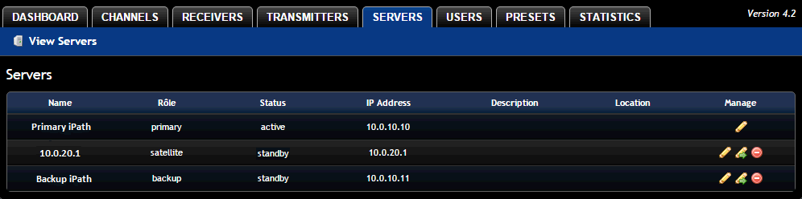

**How to setup a Satellite iPath:**The default IP address for the iPath is 169.254.1.3. It is highly recommended that you directly connect to the Satellite iPath while initially setting up. This is to prevent the Primary iPath from taking control prematurely.

1. Setup the DHCP server. You must choose an IP address for the Satellite iPath, one that is out of the DHCP pool scope on the subnet. The chosen IP address needs to be added to DHCP option 125 on all DHCP servers that service the Agility network. Please read the “Understanding DHCP Option 125” section of this document.
2. Upgrade/Downgrade the firmware if necessary. You can find the current version of iPath firmware installed at the bottom of the web interface. To upgrade, navigate to **Dashboard>>Updates**. Upload the appropriate iPath firmware and reboot when requested.
3. Check that the end point license is the same on the Primary iPath and soon to be Satellite iPath. Navigate to **Dashboard>>Settings>>General**. At the bottom of the page is a license section that informs you of the number of supported endpoints. It is very important that they are the same. You can purchase additional endpoint licenses if required.
4. The cluster authentication must be disabled on the Primary iPath. Navigate to **Dashboard>>Settings>>Servers** on the Primary iPath. Click on “No” for “Require Authentication” and press Save.
5. Perform a full Factory Reset on the Satellite iPath. Please see the “How to Factory Reset an iPath Controller” section for instructions. Shutdown the Satellite iPath when done.
6. Connect the Satellite iPath to the Agility subnet and turn it on. Upon boot, the Satellite iPath will establish its IP address from Option 125 in the DHCP server and make contact with the Primary iPath.

The Primary iPath will synchronize its database with the Satellite, during which you can monitor its progress viewing the Servers page on the Primary iPath. The Satellite iPath will show “Initializing” during the synchronization process and “Standby” when it has finished. Depending on the size of the database, this can take up to 30 minutes to perform (usually 10 minutes).

**How to Factory Rest an iPath Controller:**Some iPath configuration settings are only available when it is first setup and cannot be altered afterwards. The multi-subnet feature for example is one of those.

*Note: After factory resetting the iPath, it will be assigned an IP address of 169.254.1.3. If a Primary iPath server is on the same network when the reset occurs, it will automatically take control of the iPath on reboot making it a backup server.*

To Factory Reset the iPath controller, you need to open a web browser and log into the iPath web interface.

1. Navigate to **Dashboard>>Updates** and scroll down to “Reset iPath Configuration”

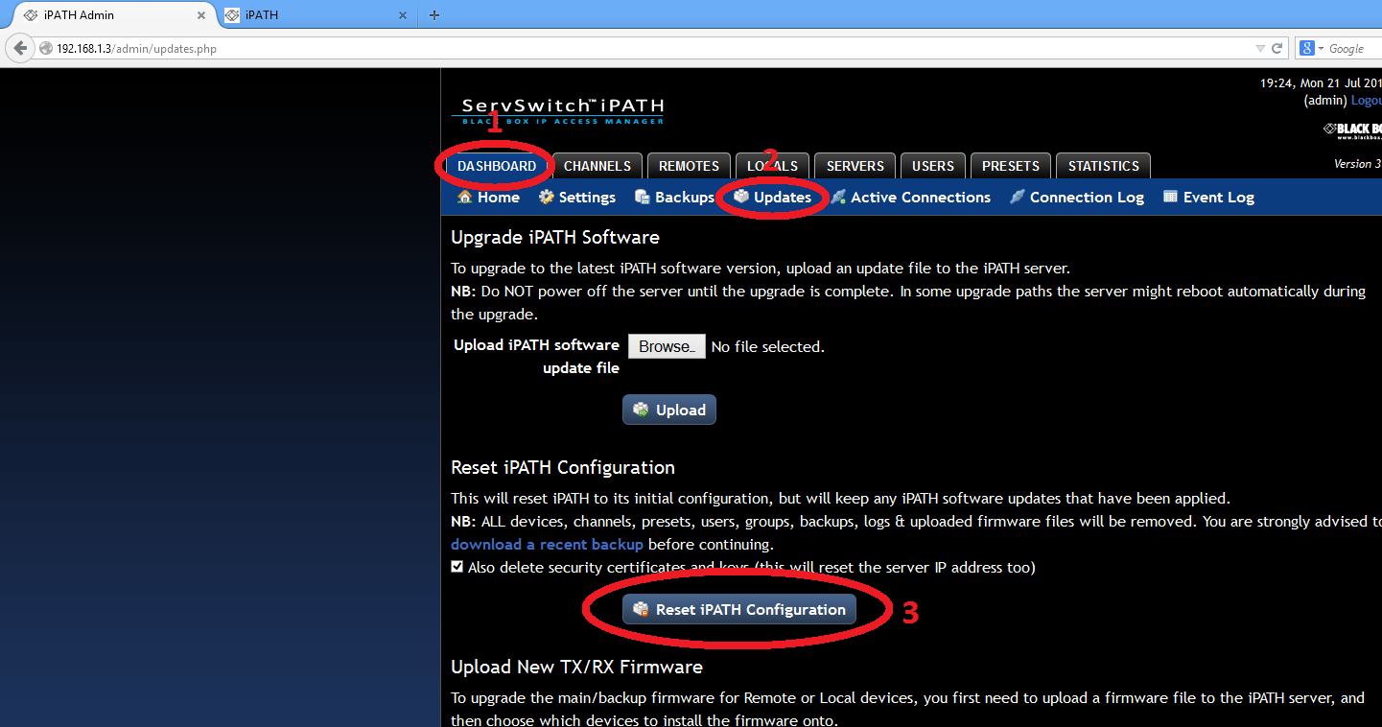

1. Tick the “**Also Reset the server IP Address**” and “**Also delete security certificates and keys**”. This is required to do a full factory reset, without which you will not be able to choose the subnet mode.
2. Press “**Reset iPath Configuration**”
3. After 1 to 2 minutes you will see a “**Restart Now**” button appear next to the Reset iPath Configuration. Press the Restart Now to complete the factory reset. If you do not restart, the factory reset will not complete.

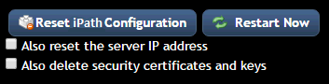

**Example DHCP Configurations:   
Example: ISC DHCPd, BlackBox, iPath Servers: 10.0.20.5, 10.0.20.6**

# ISC DHCPd configuration for BlackBox

set vendor-string = option vendor-class-identifier;

option space BlackBox code width 1 length width 1; option BlackBox.aim-servers code 1 = array of ip-address;

option space vivso code width 4 length width 1; option vivso.iana code 0 = string;

option vivso.BlackBox code 25119 = encapsulate BlackBox;

option option-125 code 125 = encapsulate vivso;

default-lease-time 3600; max-lease-time 7200;

log-facility local7;

class "BlackBox"

{

match if option vendor-class-identifier = "BlackBox";

}

subnet 10.0.20.0 netmask 255.255.255.0

{

pool

{

allow members of "BlackBox"; vendor-option-space BlackBox;

option domain-name "customer.com"; option domain-name-servers 10.0.20.2; option routers 10.0.20.1;

option vivso.iana 01:01:01;

option BlackBox.aim-servers 10.0.20.5,10.0.20.6; range 10.0.20.100 10.0.20.200;

}

}

**Example: Cisco IOS DHCPd, BlackBox, iPath servers: 10.0.20.5, 10.0.20.6**

ip dhcp pool vlan20

network 10.0.20.0 255.255.255.0 default-router 10.0.20.1 option 60 ascii "BlackBox"

option 125 hex 0000.621f.0a01.080a.0014.050a.0014.06

**Example: Setting up DHCP on Microsoft Windows Server 2012:**

* Open the DHCP server configuration console (found within administration tools)
* Expand the server tree in question on the left hand side.
* Right click the IPv4 object in the left hand tree and Select “Set Predefined Options”
* With the Option Class set to “DHCP Standard Options” add in a new option 125 and label accordingly
* Within the DHCP server option, enable this option and add the relevant details accordingly, **i.e. 0000621f0a0108C0A80114C0A80115** (with the HEX IP address updated)
* For our setup to take immediate effect a restart of the DHCP service is required.