Update Instruction

Install the update software ValUE
Need to install to the update software of ValUE 2.14.10 on the PC before try update.

Connection
- Connect TX unit to RX unit via a CAT x cable.
- Change the Mode switch on both of TX and RX units to Update position, making the units working on Update mode.
- Connect PC to the RS232 port on the TX(or RX) via a USB-to-RS232 cable.
- Connect power adaptor to the RX unit to power on the units and make sure the Link is OK.
See below picture.
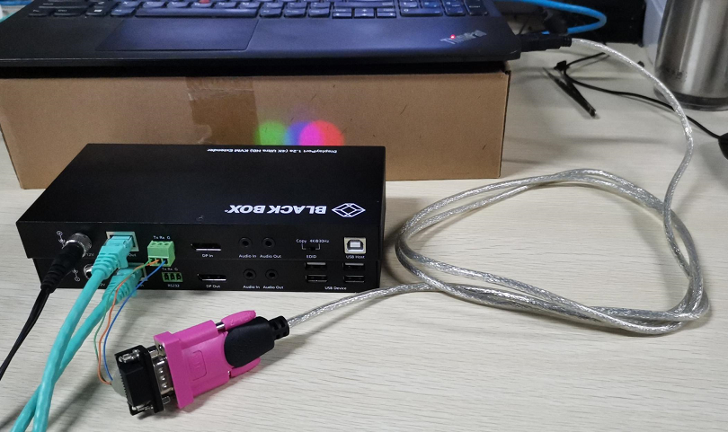
Check and confirm the COM port settings
Access to the Computer Management page to
- The COM number should not be higher than COM 10, please change it to a lower one(Such as change it to COM 1) if the COM number is higher than COM 10.
- Check and change the Latency Timer to 1msc for the COM number. If not, it will spends much more time to do the updating.
Need access to the Computer Management page to do above settings. See below pictures
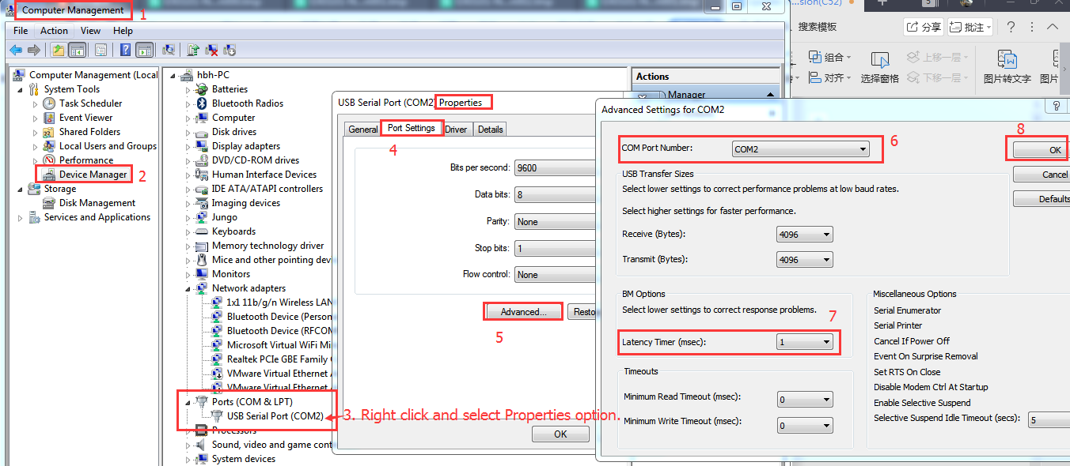

Steps for updating.
Running update software of on the PC and do as below steps shown on pictures.
Update for TX(2010TX)
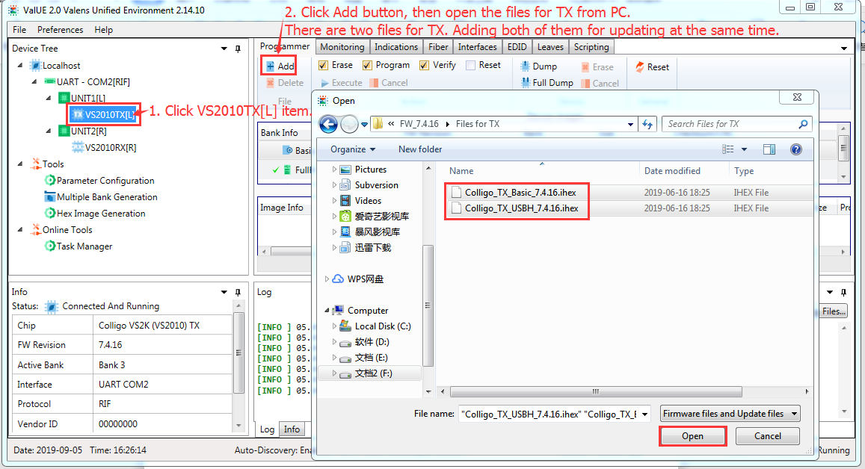
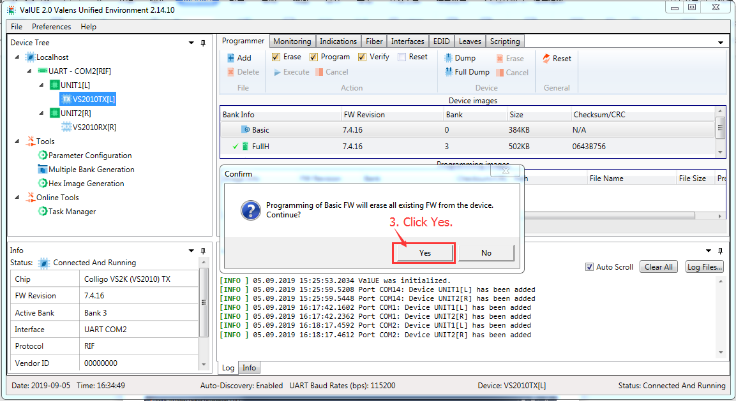
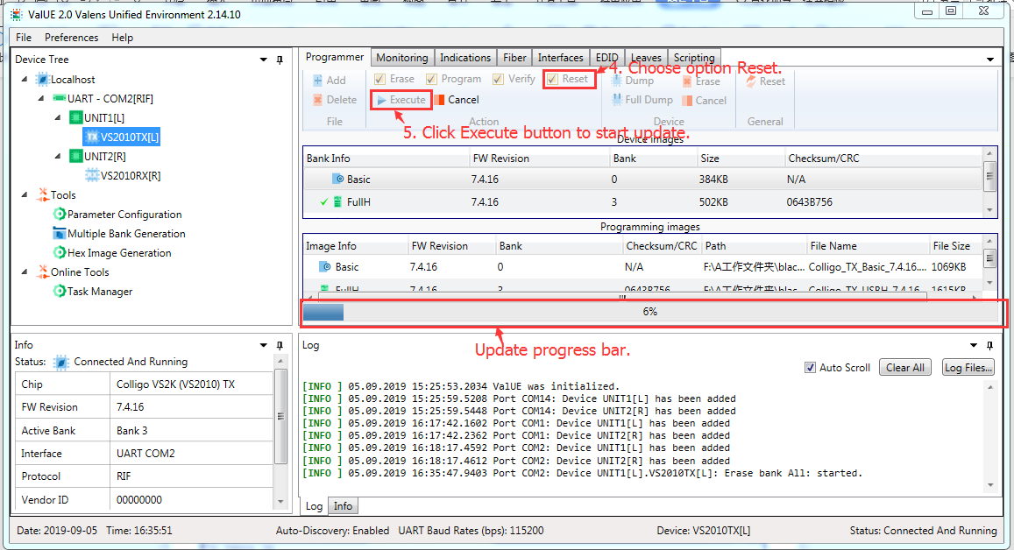
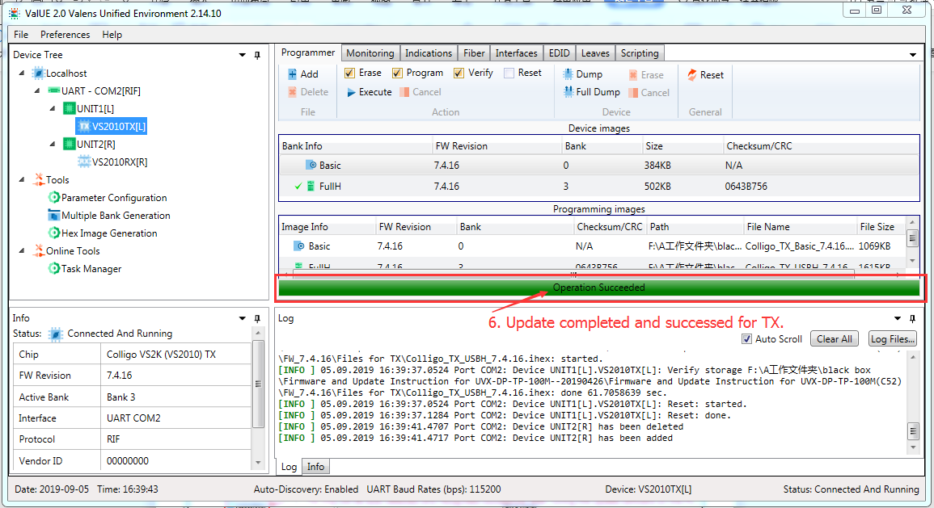

Update for RX(2010RX)
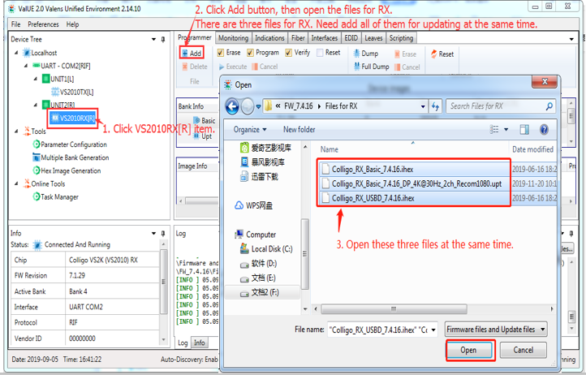
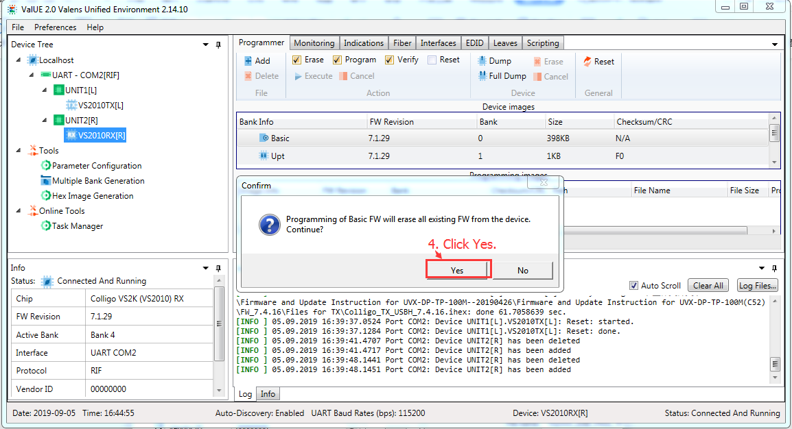
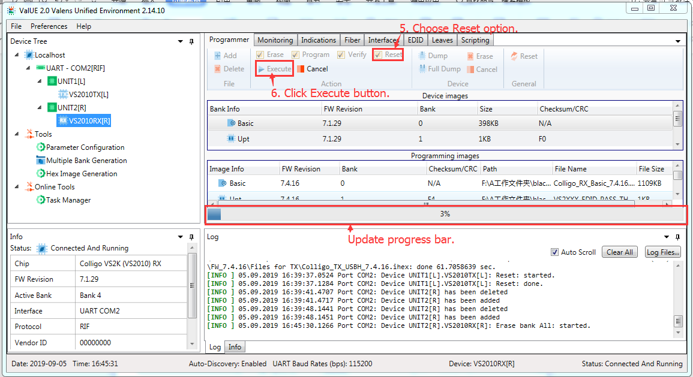
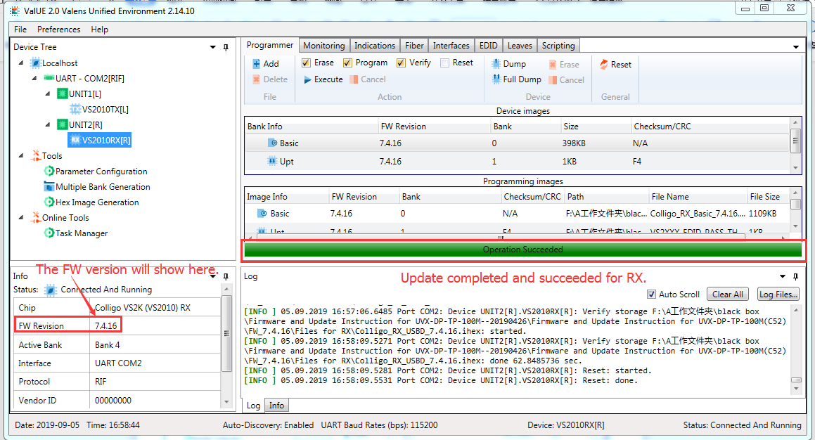

Note, change the Mode switch back to Normal position after complete update for both of TX and RX, then reboot the unit.

